Job Description – Facilities and Maintenance
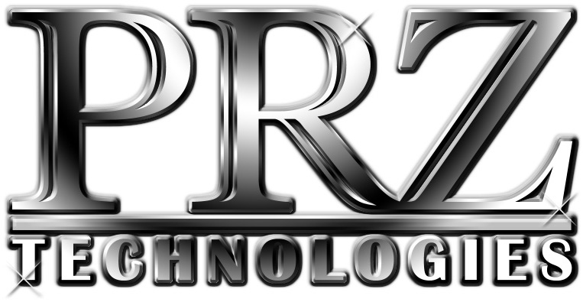
P.O. BOX 369 / LANCASTER, NY 14086
PHONE: 716-683-1300 x 200
WEBSITE: www.prztech.com
EMAIL: Jessica.messmer@prztech.com

Company Summary
PRZ Technologies, Inc. designs and builds work holding, fixturing, tooling and special machines for the CNC machine tool industry. We rely on ingenuity and creativity to produce the finest components available. All PRZ Technologies employees possess self-motivation and a team spirit.

Benefits Offered
Full-time PRZ employees receive full health insurance benefits, 11 days of paid time off after a full year of employment, six major holidays, and after one year of employment, a 401K with up to 4% company match. PRZ also offers supplemental disability and other insurances.

Organizational Information
Job Title: Facilities & Maintenance
Salary: Commensurate with ability and experience
Merit raises and year-end bonuses are often awarded based on performance

Job Summary
This position reports to the Shop Supervisor, however may need to take instruction from other management members, in cases of conflicting priorities defer to the shop supervisor. The Position requires janitorial and building maintenance needs a secondary responsibility involves coordinating shipments to & from vendors and customers as the need arises. Position will require some heavy lifting, attention to detail and some industrial or construction trade knowledge. This position requires a fast-moving pace and a willingness to perform other tasks not specifically outlined in this job description.

Job Requirements:
Candidate must be able to communicate with management and team members effectively. Have strong interpersonal skills. Ability to work in a team environment and comfortable with sharing and listening to others’ opinions and ideas. Ability to work with minimal supervision. Ability to lift 50lbs. Have a valid New York State Driver’s License. Be able to operate forklift, floor scrubber, and other maintenance machines. Must be able to problem solve, make small repairs quickly and correctly.

Duties and Responsibilities

Maintenance:
- Adhere to regular cleaning and maintenance schedule, to include the following general tasks:
  - Weekly Bathroom & break area cleaning
  - Weekly Garbage Disposal
- Clean Common Areas – Hallways, stairwells, entrances, etc. as required
- Clean Shop Floors throughout entire Building as required
- Maintain Cleaning Supply Inventories
- Wash Exterior windows yearly inside and out.
- Help with Coolant Changeout and Machine Cleaning as required
- Clean and maintain Fork Truck Records
- Other Related building maintenance, organizing and cleaning as required
- Seasonal outside cleanup, safety and maintenance, including:
  - Year-round weeds and overgrowth trim, edge, etc.
  - Spring Clean-up around property as required
  - Fall leaf and debris clearing
  - Snow removal on sidewalks and driveways, clean-up after plowing, salting as required
- General tasks as required on adjoining apartments and properties
- See attached for a more complete listing

Shop Logistics:
- Coordinate services and shipments to/from Vendors as required
- Properly Crate, Skid, Box and Protect parts for type of shipment required
- Maintain shipping supply inventories
- Maintain the Stock Area in an Organized and Clean manner.
- Maintain Storage Area’s in an Organized and Clean manner.
- Maintain the Annex area in a manner that allows for organized and efficient material flows in and out of building.
- Prepare raw material and distribute as required (aka sawing, sorting and moving material around the shop)
- Chip disposal and management as required
- Recycle and Scrap management
- Manage Dumpster Area
- Load/Unload Trucks as required
- Must be able to secure loads and safely drive PRZ company utility vehicle or rental trucks, etc.

Facilities Duties

Offices:
- Vacuum, dust, wipe woodwork every 2 weeks
- Check and empty office trash twice weekly
- Put recycling out – Wednesday morning & back in after lunch
- Wash floors monthly

Common areas:
- Vacuum, dust, wipe woodwork monthly
- Clean stairwells, steps, handrails, walls monthly
- Wash floors monthly (or as needed)
- Wash exterior windows inside & out twice/year and in between as needed

Bathrooms:
- Mop floors, wash walls (tile) weekly
- Clean fixtures weekly
- Wipe woodwork weekly

Kitchen(s)/ Lunch Room:
- Mop floors weekly
- Clean fixtures & appliances inside and out weekly
- Remove and dispose of all food, containers, etc. from refrigerators every Saturday
- Wipe woodwork weekly
- Clean tables and chairs weekly (more if needed)
- Check and empty all kitchen/break area trash twice weekly
- Monthly meeting preparation & clean up

Roof:
- Clear drains weekly

Machine Shop:
- Major clean (1) machine/area per week
- Run floor machine weekly in shop
- Run floor machine weekly in basement
- Clean areas around belt sanders/buffers
- General clean 1/3 shop – floors, corners, under machines, benches toolboxes, etc. new pig mats, clean floor mats, etc.
- Clean ramp to basement weekly
- Keep dumpster area clean and organized

General:
- Change bulbs as needed (most are LED)
- Clean Server Room as needed
- Break down cardboard for recycling

Maintain Cleaning Cart (Stock):
- Garbage bags (drum liners, office liners, drawstring kitchen)
- All-purpose cleaner
- “Magic” sponges
- 3M sponges/scrubbies
- Rubber gloves
- Mop/bucket/wringer
- Broom/dustpan
- Toilet brush/cleaner
- Glass cleaner
- Hand soap
- Paper towels

Quarterly Duties:
- Steam clean bathroom tile floors/grout quarterly
- Clean walls, light switch plates, door knobs, all interior glass, AC ducts/returns, etc. in offices, bathrooms and common areas quarterly
- Wipe light fixtures & clean lenses in offices, bathrooms and common areas quarterly
- Scrub/wax main hall
- Steam clean showroom floor

Yearly Duties:
- Steam clean office carpets (Yearly)
- Scrub/wax main hall
- Steam clean showroom floor

Apartment Maintenance:
- Basic repairs
- Painting
- General cleaning
- Damage assessment if needed

Building Maintenance (aside from regular cleaning):
- Basic repairs: plumbing, electrical
- Basic carpentry & repair
- Painting
- Other duties as assigned

